### OXFORD COGNITVE THERAPY CENTRE DIRECTIONS

**By Car:**

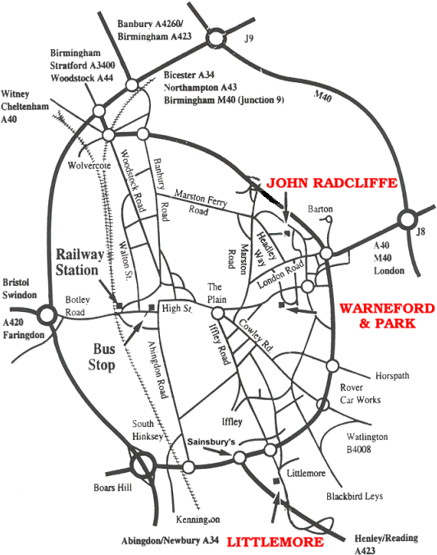

The Warneford Hospital is in Headington, 2 ½ miles east of Oxford City centre. It is reached easily from the M40.

* From the east, Junction 8 or Junction 8a, take the A40 then A420 to Headington Centre and follow signs.
* From the north, Junction 9, take the A34 then A40 northern ring road to the Marston junction (B4150), then turn left onto the B4495 towards Headington and follow signs.

From the south and west, approach from the Eastern ring road and B4495.

See the next page for a more detailed map of the city.

**On Arriving at the Warneford Hospital Site:**

Cars can enter the Warneford Hospital Site off Roosevelt Drive (see below). You will need to park in the spaces at the front of the hospital and buy a pay and display ticket, If there are no pay and display places left then buy a ticket and park in the permit holders area. On foot follow signs for Outpatients Department, the road bending round to the right hand side of the main hospital building. The OCTC is in a low level building near the chapel on the Warneford lane side of the site.

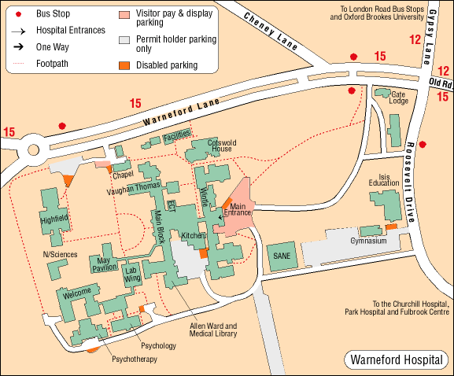

**McInnes Room**

**(upstairs)**

**OCTC office**

**(above Outpatients Dept)**

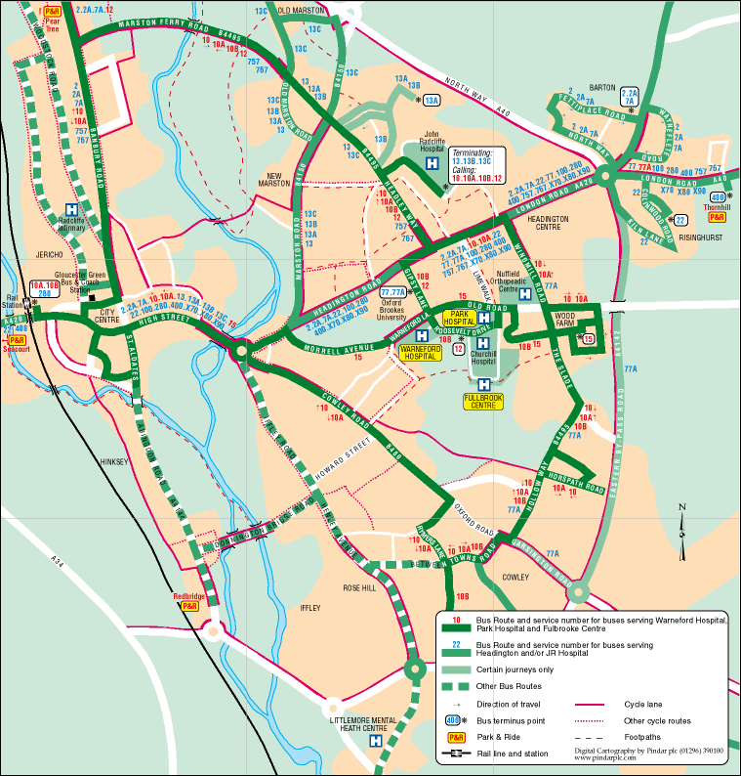

**Main Entrance to the OCTC**

**The office is normally staffed between the hours of 8.30am & 4.30pm.**

**Please ring the bell to enter.**

